Smartinternz externship



Data Analytics with IBM cognos Analytics

Assignment 4

**Name:** MOUNIKA SATYA PRASEEDA KALLAKURI

**Email ID:** [praseeda.21bce9173@vitapstudent.ac.in](mailto:praseeda.21bce9173@vitapstudent.ac.in)

**Registration Number:** 21BCE9173

**BASIC CALCULATIONS**

Here are some of the basic calculations performed on the ***Global Superstore*** dataset over Tableau:  
  
***1. Profit Ratio***

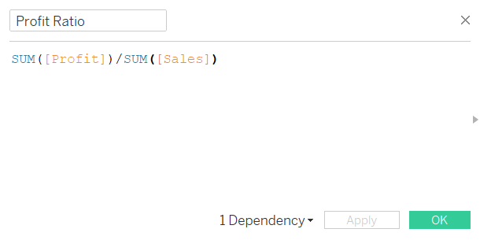

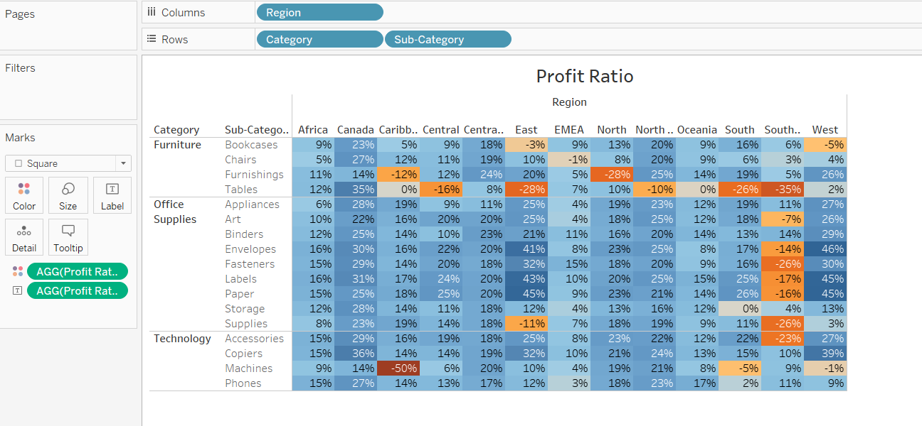

1. ***New Customer Acquisition***

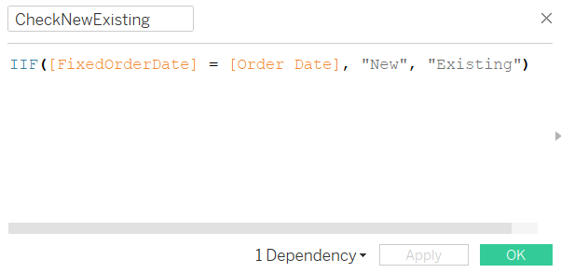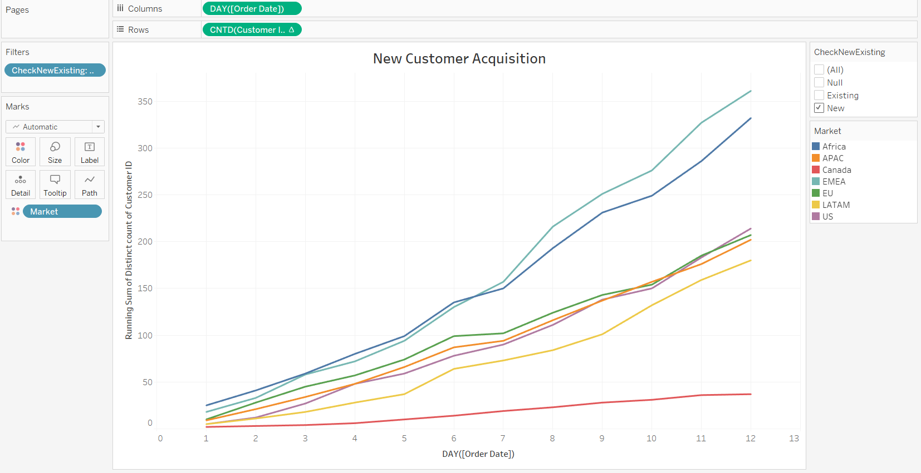

**LOD EXPRESSIONS**

Here are some examples of LOD expressions used on the ***Global Superstore*** dataset over Tableau:

1. ***Customer Order Frequency***

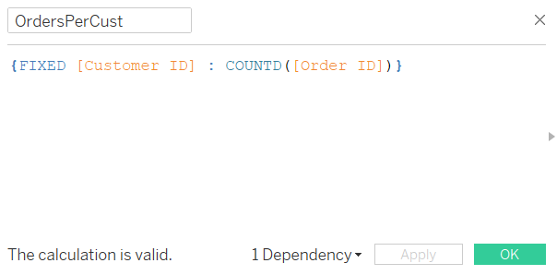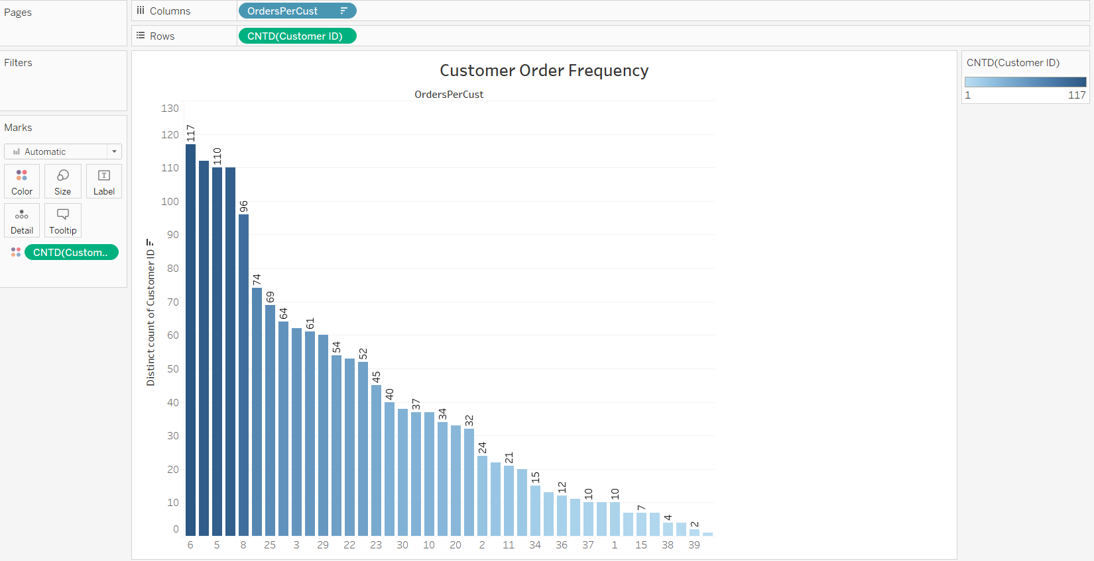

***2. Repetitive Orders by Old Customers (Quarterly Purchases)***

